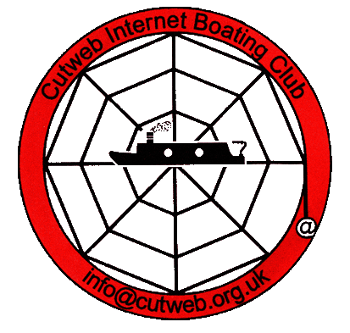
Cutweb Rally 2017
What's on when!

Friday...... arrival. If you need to pay for a camping pitch or an electricity hook-up pay at the bar as soon as you can.
Evening, meet in the bar from 7pm. If you want a meal, order at the bar from the usual pub menu. http://www.bluelias.com/menu.pdf - menu is not up-to-date however -
Saturday...... Bring and share lunch at 12.00. on the lawn or in the function room. Please bring your contributions for the table and your own eating irons. Drinks will be available from the pub.
If you want to order a Sunday roast please see Diana Holt, nb Harnser. The cost will be £8.50 and orders must be in by 5pm at the VERY latest.
General silliness organised by the Heavens, nb Just Heaven during the afternoon, please join in. If you have an outdoor or indoor game you'd like us to play - bring it along.
If you have any raffle prizes for the evening please wrap them/disguise them, and deliver them to Connie Evans, caravan corps, during the day. An opportunity to get rid of last year's collection of tat and Cutweb raffle prizes.
Evening..... In the function room. Because of depleted numbers we have THE QUIZ as the star turn, our question maestros are John and Liz, nb Black Pig. There will be the infamous raffle and a buffet supper during the interval. Supper is included in your rally entry fee. There will be gherkins, free to hecklers and nuisances.
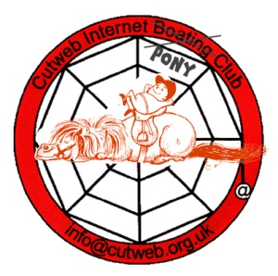
Sunday.... The Auction in the function room. Please bring your lots to the function room before 10am. Bidding will start at 10.30 am. If you have items that you want to sell on a commission basis please label them with the price wanted and your name. Give them to Graham, nb Jannock. Our porter this year doesn't know who he/she is.....yet! We do.
Lunch in the function room at 1 pm. Desserts can be ordered IF you have room after your mains.
Evening in the function room. At 7pm we have the inaugural meeting of the Cutweb Pony Club! ( You don't need a boat OR a pony to join Cutweb!) Please bring along your own snacks and any leftovers from Saturday lunch to fill your nosebags. There will be horse races and gambling! ( You don't need money for that either) The Cutweb Pony Club Sirloin Stakes Presentation Plate will be, erm, presented. This event requires teams of 2, neither being a jockey.

Important Information. updated 2016
Our location is Blue Lias Inn, Stockton Road, Stockton, Southam, CV47 8LD
Tel: 01926 812249
Info about Southam: http://www.southamonline.org.uk/

Rubbish bins. CaRT bins are located near the entrance to the fishing lake at the rear of the pub.
The lake is a pleasant walk if you have half an hour to fill. Blackberries may feature, so take a bowl.

In an emergency, when there is a crime in progress or a life at risk, always call 999
To report less urgent crime or disorder call 101, the non-emergency number.
If someone is ill and you are unsure what to do NHS Direct 0845 46 47
Southam Police Main telephone number: 01926 684984
Team email: southam.snt@warwickshire.police.uk Website: www.warwickshire.police.uk
FIRST AIDERS: Simon and Karen Witwicki staying on Just Heaven
Doctor:- Northfield Road, Southam, Warks, CV47 0FG
Telephone 01926 810939 Out of Hours 0333 200 2502
Urgent when closed at Lunchtime Please ring the surgery telephone number (01926 810939) for instructions
Doctor: ,Stowe Drive,Southam,Warks, CV47 1NY
Tel: 01926 815842 Emergencies:at any time - 01926 815842
If your call is urgent please call the surgery. If the surgery is closed a recorded message will be available with details of the emergency out of hours service. Please have a pen and paper available.
Southam Pharmacy 1 Market Hill, Southam, CV47 0HE. Telephone 01926 812287
Opening hours: Thursday: 09.00-18.30, Friday: 09.00-18.30, Saturday: 09.00-17.00. Lunch 13.00 – 13.30
Sunday, closed

Hospital: Lakin Road Warwick CV34 5BW http://www.swft.nhs.uk/
main switchboard - telephone: 01926 495 321, A&E reception (general inquiries) ext. 4032
Veterinary There are 2 vets in Southam, but West Bar is only open 16.00 – 18.30
Avondale: 4 The Cobalt Centre, Kineton Road, Southam CV47 0FD Tel: 01926 812826
Monday – Friday 8.30am to 6.30pm Saturday 8.30am to 12.30pm
Places of Worship

St James C Of E Church Park La, Southam CV47 0JA 01926 812413
http://www.stjames-southam.co.uk/
Sunday Service Times:
8am - Holy Communion (BCP).
10am - Morning Worship, All-Age Service or Holy Communion.
6.30pm - Evensong or Holy Communion.
Our Lady & Saint Wulstan, Catholic Church Daventry Road, Southam, CV47 1PP http://www.stwulstan-southam.co.uk/
Service times Mass Saturday 17.30, Sunday 10.00. Confessions Saturday 17.00
Southam Community Church Independant Evangelical Coventry Street, Southam, CV47 0EP
01926 811144 Sunday: 10.30
http://www.southamcommunitychurch.org.uk/
Southam Congregational Church http://www.southamcongregationalchurch.org.uk/
Wood Street, Southam, V47 1PP Sunday 10.30

Banks Coventry Building Society, HSBC and Lloyds are in Southam
Sunday Lunch Order form

Name Boat

Number of Sunday Roasts @ £8.50p =
Number of vegetarian meals (Choose from menu and pay when ordered) =
Special requests (please detail here) =

Please submit this form to Diana aboard nb Harnser before 5pm Saturday.

Thankyou.

